## Problem

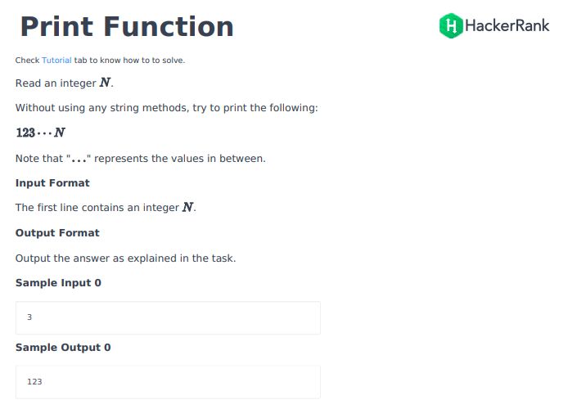

## Solution

from __future__ import print_function

if __name__ == '__main__':

    n = int(raw_input())

a=[]

if n <= 150:

    for x in range(1,n+1):

        a.append(x)

my_lst_str = ''.join(map(str, a))

print(my_lst_str)

## Python3

if __name__ == '__main__':

n = int(input())

for i in range(1,n+1):

print(i,end='')